WEEK1 SKILL
Session1:
- To Install Linux VM, Configure GCC, Setup Git Repository, Create Project Structure, Understand Shell Architecture, Build Initial Makefile.

Task -1: Create Project Structure as follows:
Note: For creating this structure use mkdir and touch commands.

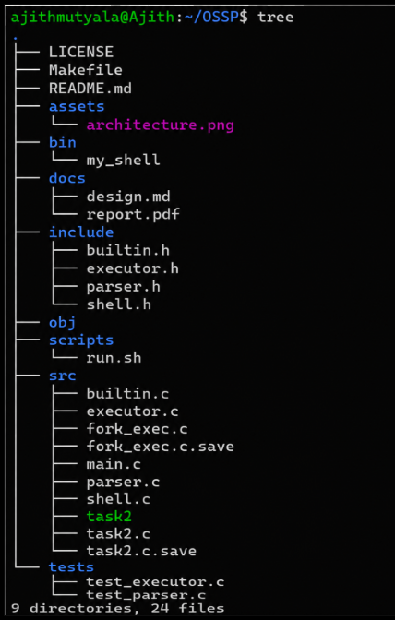

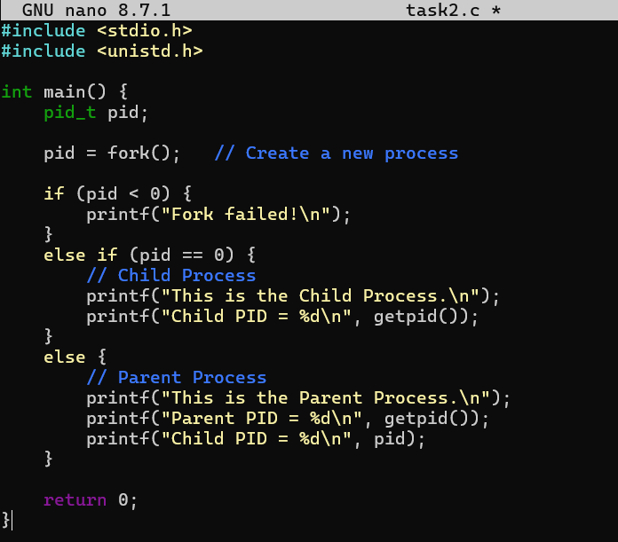

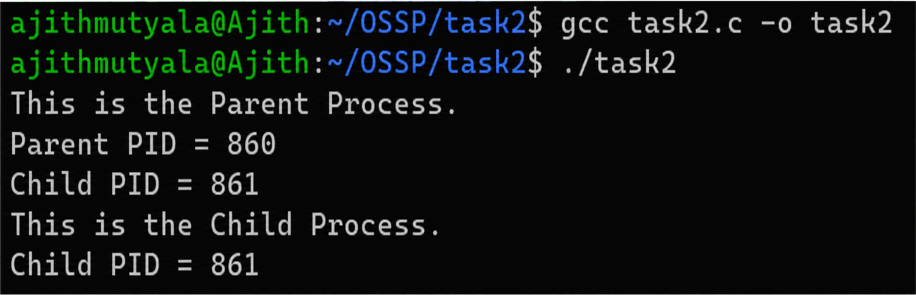

Report: I created the necessary folders and files, initialized a Git repository, and verified the project structure using the tree command. Thus, I successfully completed the task and understood how to organize a project in Linux.

To Analyze process abstraction, execute fork(), understand exec() family, analyze parent-child relationships, inspect process tree, practice system call tracing.

Task-1: Using a manual command understand the fork() and exec() system calls

Fork()
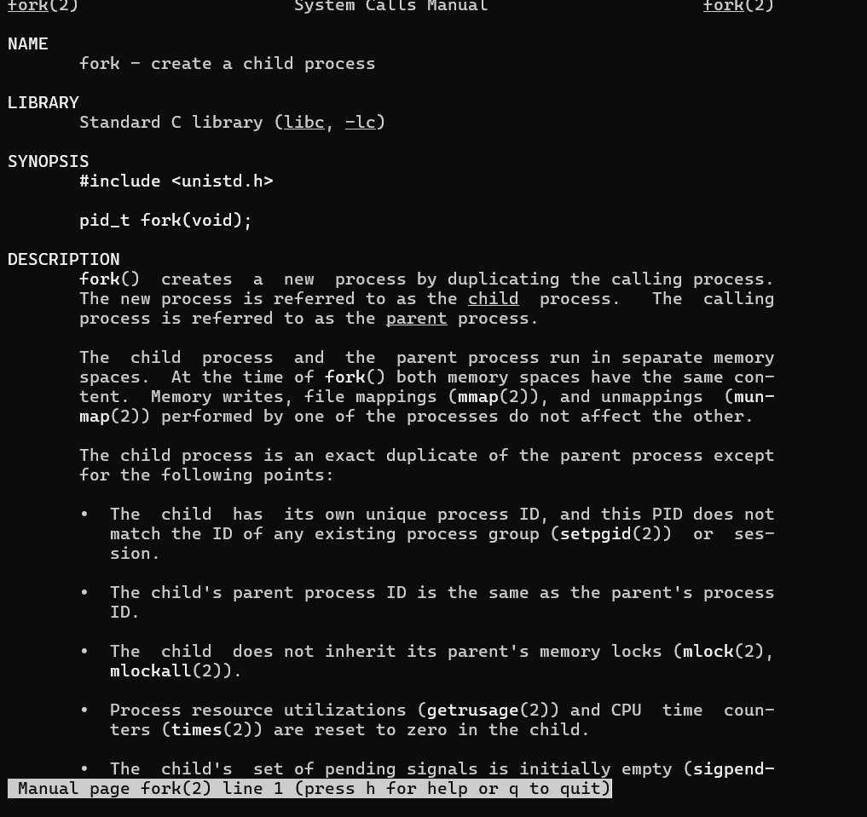

Man exec:
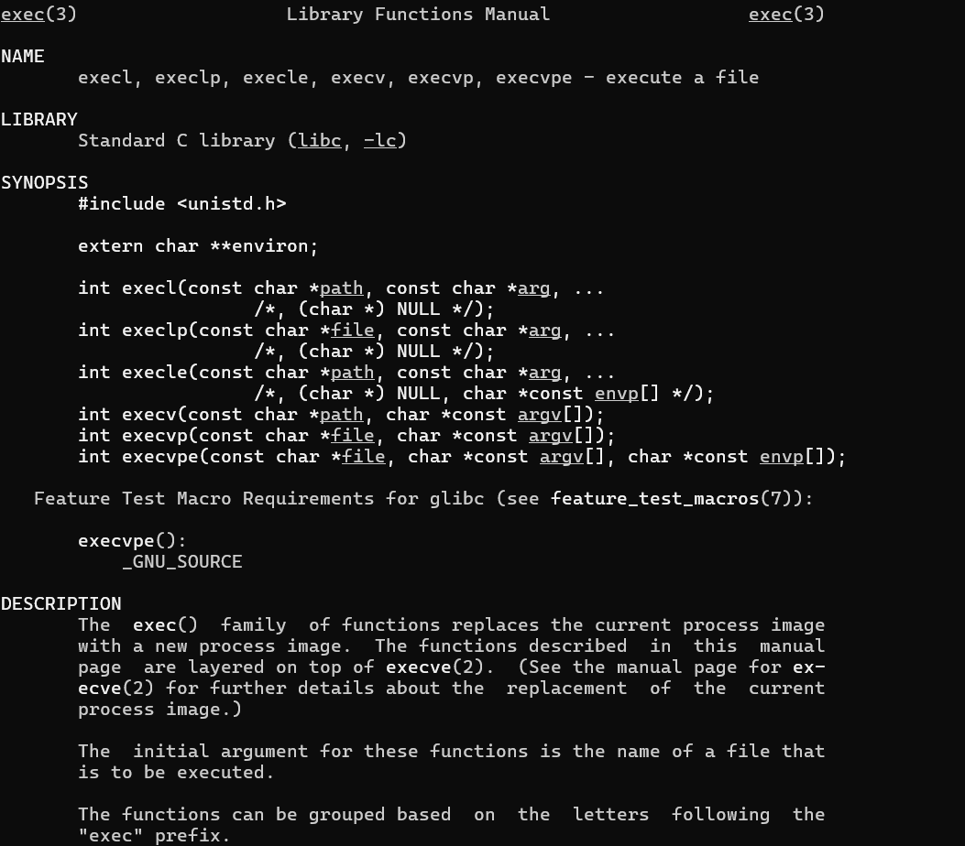

Report: I used the manual commands man fork and man exec to understand the fork() and exec() system calls. I read the manual pages and learned that fork() creates a new child process, while exec() replaces the current process with a new program. Thus, I successfully understood the purpose and working of both system calls.

Task-2: Write a C program to create a new process and accepting the user commands using fork() and exec() system calls.
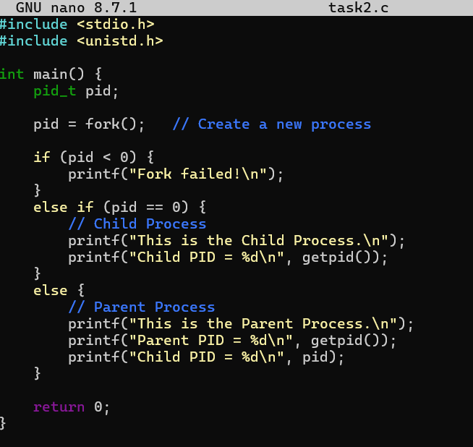

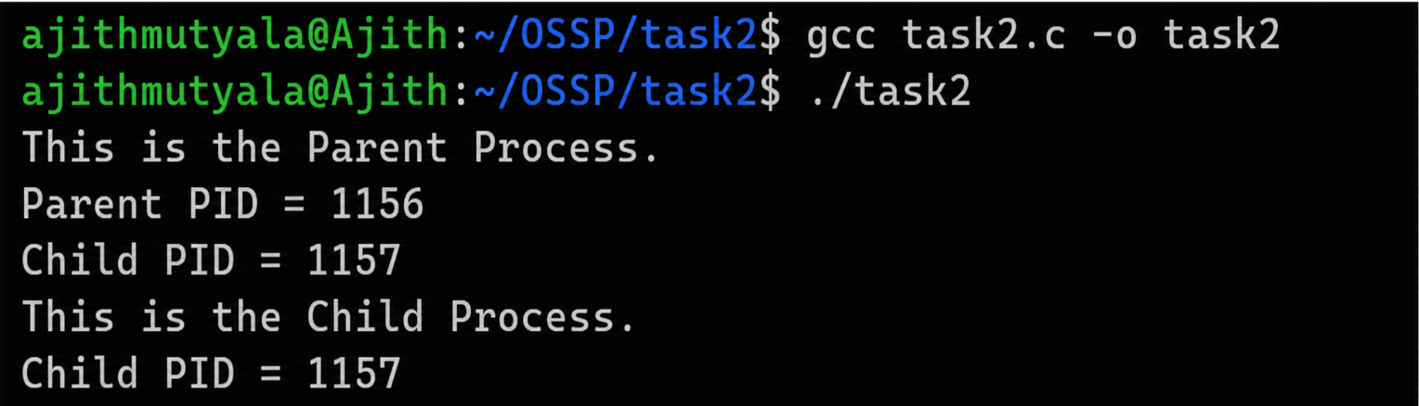
Report: I wrote and executed a C program using the fork() system call to create a child process. I compiled and ran the program successfully and observed the creation of both the parent and child processes along with their Process IDs (PIDs). Thus, I understood the working of the fork() system call and the parent-child process relationship successfully.

SESSION 2:
- To Create Main Loop, Display Prompt, Read User Input, Handle Exit Conditions, Design Control Flow Diagram, Test Interactive Loop
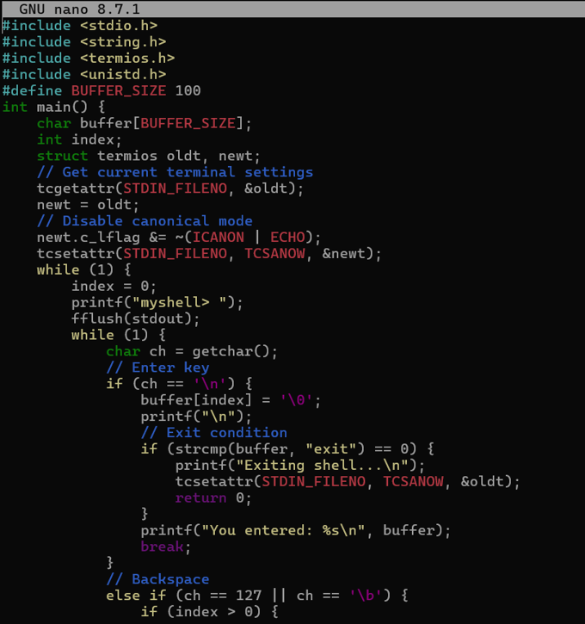

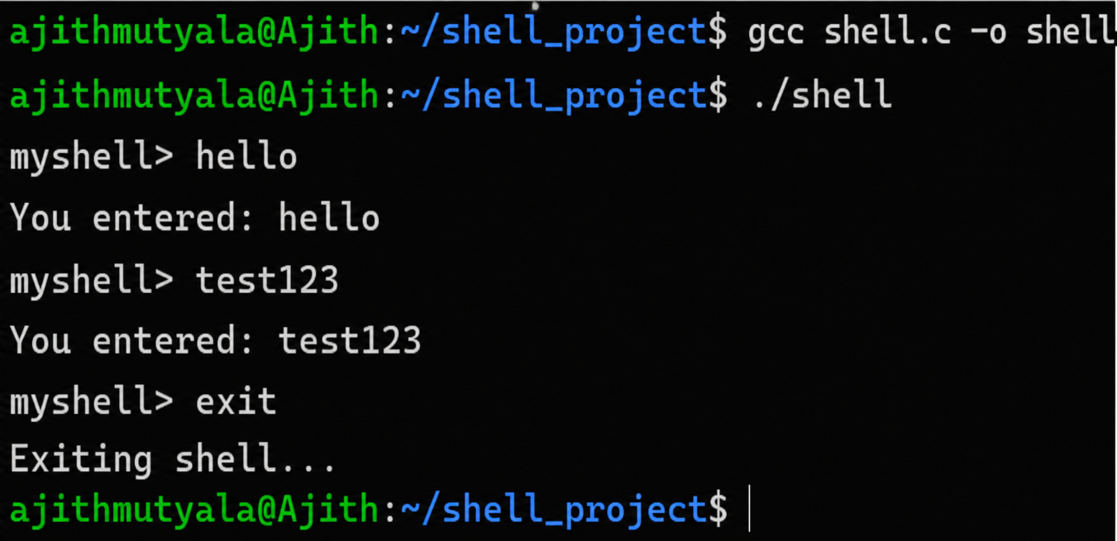
Report: I compiled and ran the shell program and tested it with the inputs hello, test123, and exit. I observed that the shell correctly displayed the entered commands and exited when the exit command was given. Thus, I successfully implemented and tested the main loop, user input handling, and exit condition of the shell program.

- To Capture Keyboard Input, Handle Backspace, Process Enter Key, Manage Input Buffer, Support Multi-Character Commands, Test User Interaction

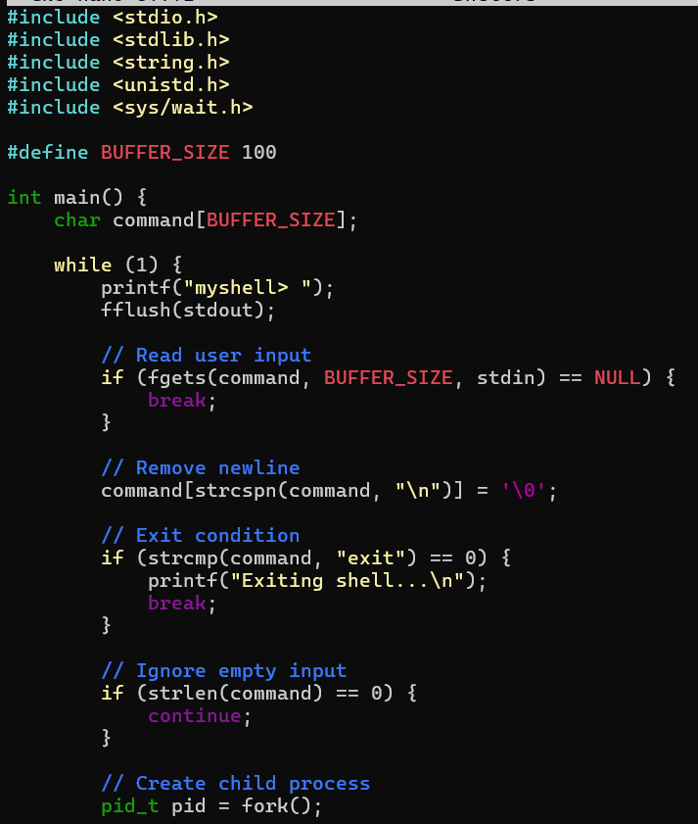
Report: I wrote and executed a C program using fgets() to read user input, handled the newline character, implemented the exit condition, and created a child process using fork(). Thus, I successfully implemented the main shell loop, user input handling, exit condition, and process creation.
make
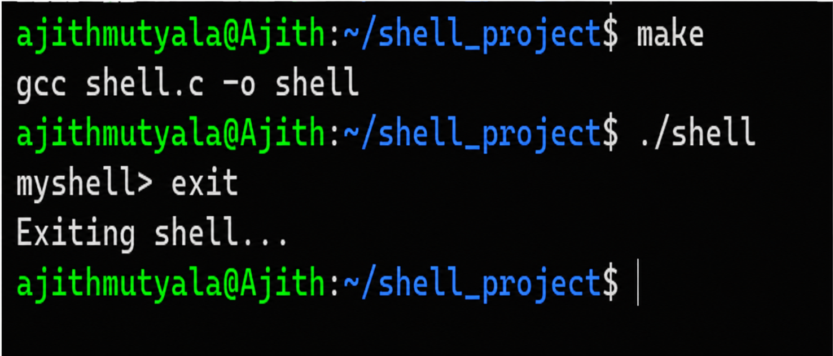

Report:
I compiled the shell program using the make command and successfully executed it. I tested the exit command and observed that the shell displayed the exit message and terminated correctly. Thus, I successfully built and tested the shell program and verified its exit functionality.

backspace
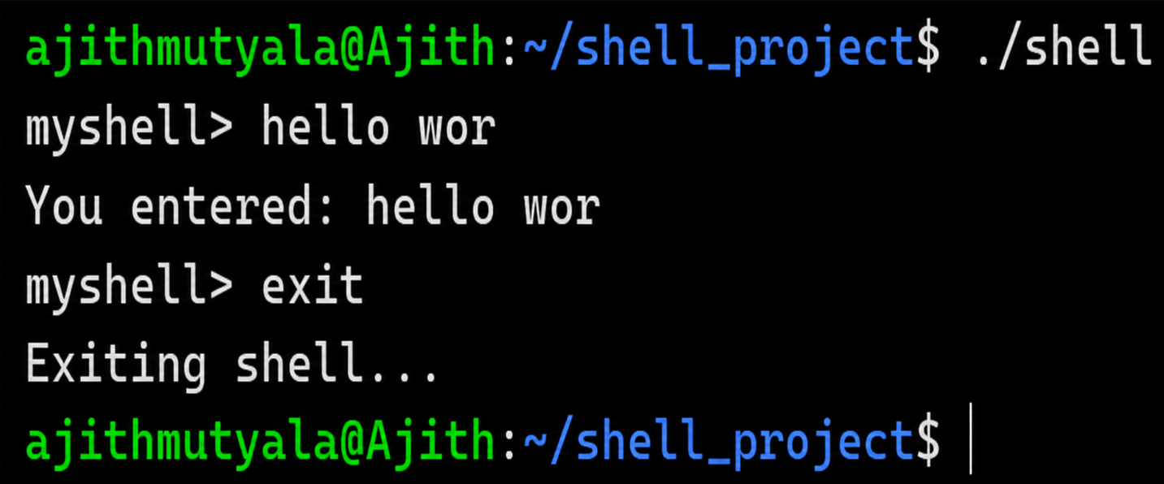

Report: I executed the shell program and tested it with a multi-character input, hello wor, and the exit command. I observed that the program correctly displayed the entered input and terminated successfully when exit was given. Thus, I successfully tested multi-character command input and the exit functionality of the shell.
fork()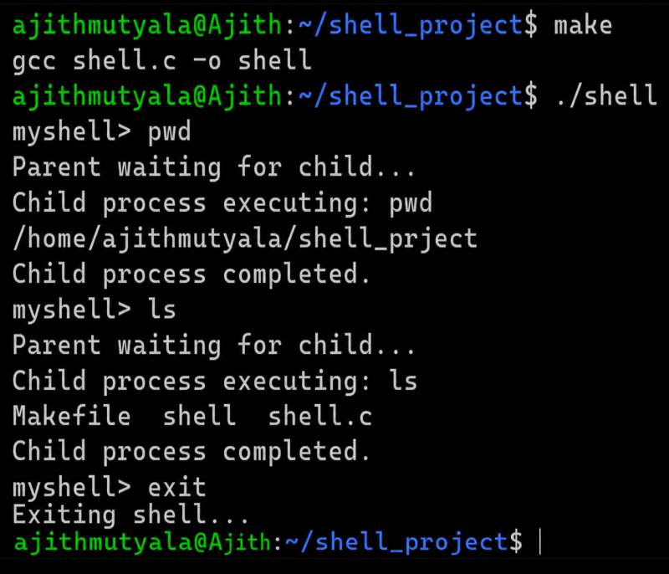

Report: I compiled and executed the shell program and tested it with the pwd and ls commands. I observed that the shell successfully created child processes, executed the commands, and waited for the child processes to complete before accepting the next command. Thus, I successfully implemented and tested command execution using fork(), exec(), and wait().

